Data Classification Using Artificial Intelligence

Project Report

DecodeLabs Industrial Training Program 2026

Student Information
Student Name: Muhammad Jawad
Program: Bachelor of Science in Artificial Intelligence
University: FAST National University of Computer and Emerging Sciences
Internship Organization: DecodeLabs
Internship Program: Industrial Training Program 2026
Project Number: Project 2
Project Title: Data Classification Using Artificial Intelligence

Abstract
Machine Learning is one of the most important branches of Artificial Intelligence that enables computers to learn patterns from data and make predictions without being explicitly programmed. This project focuses on implementing a supervised machine learning classification model using Python and the Scikit-learn library.
The project demonstrates the complete machine learning workflow, beginning with dataset loading and exploration, followed by preprocessing, feature selection, data splitting, model training, prediction, and performance evaluation. The objective is to understand how classification algorithms analyze labeled datasets and predict the correct class of new observations.
This project provides practical experience in implementing a real-world machine learning pipeline while following professional software engineering practices.

Introduction
Artificial Intelligence has transformed modern computing by enabling systems to perform intelligent tasks such as prediction, recommendation, automation, and decision-making.
One of the fundamental techniques in Artificial Intelligence is Machine Learning, where computers learn patterns directly from data instead of relying solely on manually written rules.
Classification is a supervised learning technique used to categorize data into predefined classes. It is widely applied in spam detection, medical diagnosis, fraud detection, image recognition, customer segmentation, and many other domains.
This project implements a complete classification system that trains a machine learning model using labeled data and evaluates its performance on unseen samples.

Problem Statement
Traditional software systems require developers to manually define every decision using conditional statements.
As datasets become larger and more complex, manually defining rules becomes inefficient and difficult to maintain.
The objective of this project is to develop a machine learning classification model capable of learning from historical data and predicting the correct class for new observations with high accuracy.

Objectives
The objectives of this project are:
- Understand the fundamentals of supervised machine learning.
- Learn the concept of classification.
- Load and analyze structured datasets.
- Perform data preprocessing.
- Handle missing values.
- Select input features and target variables.
- Split the dataset into training and testing sets.
- Train a classification model.
- Evaluate model performance.
- Gain practical experience using Scikit-learn.

Scope of the Project
This project focuses on implementing a supervised learning classification model capable of predicting categorical outcomes.
The project includes:
- Dataset loading
- Data preprocessing
- Data exploration
- Model training
- Prediction
- Performance evaluation
- Result visualization
The project does not include deep learning, natural language processing, or deployment to production environments.

Technologies Used
The following technologies were used during development:
- Python 3.x
- Pandas
- NumPy
- Scikit-learn
- Matplotlib
- Seaborn
- Visual Studio Code
- Git & GitHub

System Requirements

Hardware Requirements
- Intel Core i3 Processor or higher
- Minimum 4 GB RAM
- 500 MB Free Storage

Software Requirements
- Windows 10 or Windows 11
- Python 3.x
- Visual Studio Code
- Required Python Libraries

Dataset Description
The project uses a labeled dataset for supervised machine learning.
Example Dataset:
Iris Dataset
The dataset contains measurements of flower characteristics.

Input Features
- Sepal Length
- Sepal Width
- Petal Length
- Petal Width

Target Classes
- Iris Setosa
- Iris Versicolor
- Iris Virginica
Each record belongs to one of these predefined classes.

Methodology
The project follows the standard supervised machine learning workflow.

Step 1: Import Required Libraries
All necessary Python libraries are imported.
These libraries provide functionality for data handling, visualization, model training, and evaluation.

Step 2: Load Dataset
The dataset is loaded into Python using the Pandas library.
This allows structured data to be analyzed efficiently.

Step 3: Data Exploration
The dataset is explored to understand:
- Number of rows
- Number of columns
- Data types
- Missing values
- Statistical summary

Step 4: Data Preprocessing
Data preprocessing includes:
- Checking missing values
- Removing unnecessary data
- Selecting features
- Preparing the dataset for machine learning

Step 5: Feature Selection
The input variables are separated from the target variable.
Input variables are represented as X.
Target labels are represented as y.

Step 6: Train-Test Split
The dataset is divided into two subsets.
- Training Dataset (80%)
- Testing Dataset (20%)
The training data is used to teach the model.
The testing data is used to evaluate performance.

Step 7: Model Training
A supervised machine learning classification algorithm is trained using the training dataset.
The model learns patterns between the input features and the target classes.

Step 8: Prediction
After training, the model predicts the class labels for unseen testing data.
These predictions are compared with the actual labels.

Step 9: Model Evaluation
The trained model is evaluated using standard machine learning metrics.
These include:
- Accuracy Score
- Confusion Matrix
- Precision
- Recall
- F1-Score
- Classification Report
These metrics determine how effectively the model performs.
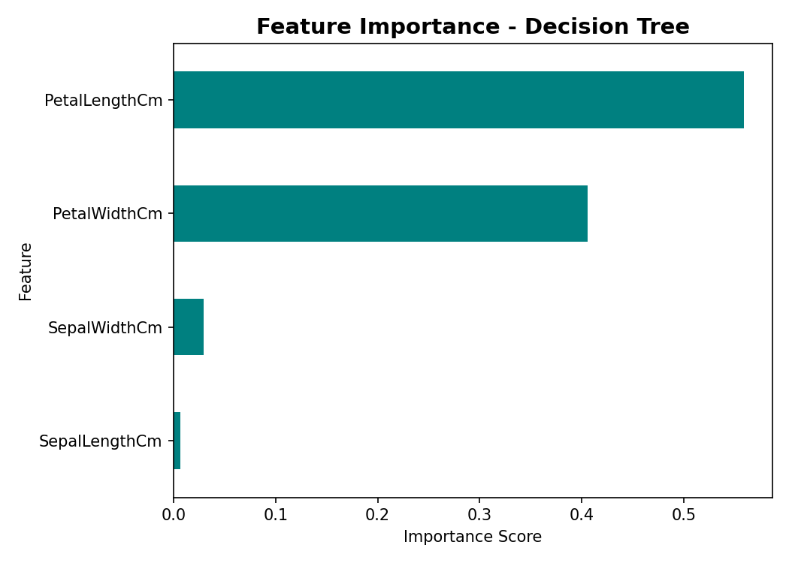

Machine Learning Workflow
Dataset
│
▼
Load Dataset
│
▼
Explore Dataset
│
▼
Data Preprocessing
│
▼
Feature Selection
│
▼
Train-Test Split
│
▼
Model Training
│
▼
Prediction
│
▼
Performance Evaluation

Classification Algorithm
This project uses the Decision Tree Classifier, a supervised learning algorithm.
Decision Trees classify data by creating a tree-like structure where each internal node represents a decision based on feature values, and each leaf node represents a predicted class.
The algorithm is widely used because it is simple, interpretable, and performs well on many classification problems.

Results
The trained model successfully learned patterns from the training dataset and produced predictions on unseen testing data.
Performance was measured using evaluation metrics such as accuracy, confusion matrix, precision, recall, and F1-score.
The obtained results demonstrate that the classification model is capable of accurately categorizing new observations based on learned knowledge.

Applications
Classification techniques are used in many real-world applications, including:
- Spam Email Detection
- Medical Disease Diagnosis
- Credit Risk Assessment
- Customer Segmentation
- Image Classification
- Fraud Detection
- Product Recommendation
- Sentiment Analysis
- Wildlife Classification

Advantages
- Learns from historical data.
- Makes accurate predictions.
- Reduces manual decision-making.
- Easily adaptable to new datasets.
- Useful for real-world AI applications.
- Improves automation.

Limitations
- Performance depends on data quality.
- Requires labeled datasets.
- Sensitive to noisy data.
- May overfit if not properly tuned.
- Accuracy varies depending on the selected algorithm.

Future Improvements
The project can be enhanced by implementing:
- Hyperparameter tuning
- Cross-validation
- Feature engineering
- Multiple algorithm comparison
- Ensemble learning methods
- Real-world datasets
- Web application deployment
- Cloud integration
- Automated model selection
- Interactive dashboards

Learning Outcomes
This project helped develop practical knowledge in:
- Artificial Intelligence fundamentals
- Machine Learning concepts
- Supervised Learning
- Classification algorithms
- Data preprocessing
- Feature engineering
- Model training
- Model evaluation
- Python programming
- Software engineering practices

Conclusion
This project successfully demonstrates the implementation of a supervised machine learning classification system using Python. The complete machine learning pipeline—from dataset loading to model evaluation—was implemented using professional development practices.
The project strengthened the understanding of classification algorithms, data preprocessing, and performance evaluation while providing practical experience with Scikit-learn. It serves as an excellent foundation for more advanced topics such as deep learning, natural language processing, and predictive analytics.

References
- Python Software Foundation. Python Documentation. https://docs.python.org/3/
- Scikit-learn Developers. Scikit-learn Documentation. https://scikit-learn.org/
- Pandas Documentation. https://pandas.pydata.org/
- NumPy Documentation. https://numpy.org/
- Matplotlib Documentation. https://matplotlib.org/
- DecodeLabs Industrial Training Program 2026 – Project Guidelines.

Acknowledgement
I would like to express my sincere gratitude to DecodeLabs for providing the opportunity to participate in the Industrial Training Program 2026. This project enhanced my understanding of Artificial Intelligence and Machine Learning through practical implementation. I also extend my appreciation to the mentors and instructors for their valuable guidance and continuous support throughout the completion of this project.

